***TASK 1:***

***VARIABLE AND TYPECASTING:***

***CODE:***

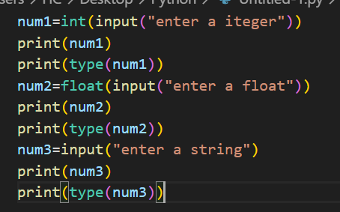

***OUTPUT:***

